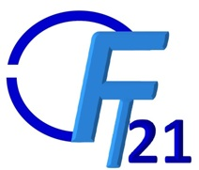

EHTICAL AND COPYRIGHT STATEMENT
INTERNATIONAL CONFERENCE ON FUTURISTIC TECHNOLOGIES 22-24 JAN 2021
Paper no :
Title :
Authors :

On behalf of all the authors, I affirm that the above paper is contributed by all the authors listed above and not published anywhere else. It does not infringe upon any copyright or intellectual property or rights of any other publisher/ organization/ individual. In case any copyrighted material is used, due permission has been granted by the copyright holder and necessary citations made in the body of the paper. In case the paper is a derivative from authors’ own journal paper, the original source is duly cited as per norms and acknowledged. I have duly checked the similarity index of the paper using online sources and affirm that it is within small limits.

On behalf of all the authors, I hereby agree to assign the rights of publishing our full-length paper in an open access online proceedings to the Organizing Committee of FT21. I understand that all authors including me still retain the original copyrights of the paper. I also agree that my oral/ poster presentation during the sessions be recorded and posted in online repository of the conference.

Signature, Name, Affiliation and Date

NOTE: Please upload signed pdf copy of the form along with full length paper.

